Trumbull boxing event raises money to help youth charity
News 12 Staff
Sep 11, 2021, 9:40pm
Updated on: Sep 12, 2021, 11:11am

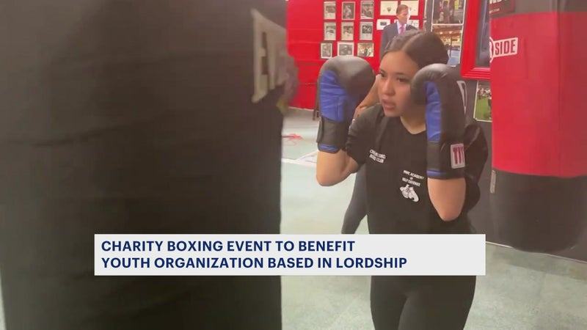
Trumbull boxing event raises money to help youth charity Sep 11, 9:40 PM

Former Bunnell football standout leans on family for first organized fight in over 10 years Sep 10, 5:39 PM

A local nonprofit that promotes hard work, discipline and fair play held a charity boxing event in Trumbull Saturday night.
The Chick Rosnick Boxing Club held the event at the Trumbull Marriott.
It featured dozens of fighters taking part in a competition sanctioned by USA Boxing, all to benefit the youth organization based in Lordship.
Mike Rosnick tells News 12 that his grandfather, a top coach and educator at the old Jewish Community Center on Park Avenue, would have been proud. "The Rosnick family is honored to have this boxing club named in honor of my grandfather and more importantly that these young adults will be taught the foundational principles that my grandfather stood for."
Proceeds from the event going to support the nonprofit effort.

