NEWS

Stratford teen headed for national boxing championships

Ethan Fry Sep. 4, 2021Updated: Sep. 4, 2021 6:22 p.m.

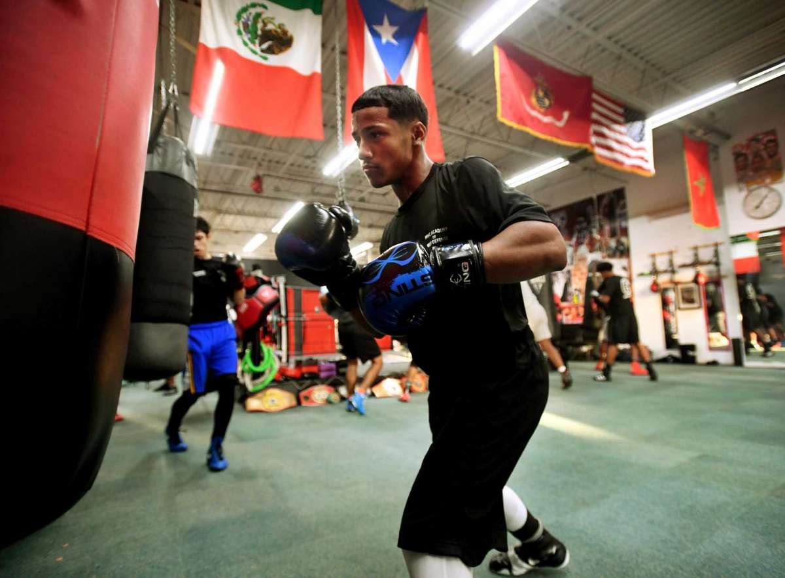
Joseph Chisholm, 15, of Stratford, hits the heavy bag along with his fellow boxers at the Chick Rosnick Boxing Club in Stratford, Conn. on Monday, August 16, 2021.
Brian A. Pounds / Hearst Connecticut Media

STRATFORD — A teenage boxer won his third regional championship last month and is headed to the national championships in December.
Joseph Chisholm trains with his father, Martin, at the Chick Rosnick Boxing Club in Lordship. His win at the regional championships in Rochester, N.Y. in August followed triumphs in 2018 and 2019. The region covers New England, New York, and New Jersey.
The 15-year-old followed that title up by going 1-1 at the National Silver Gloves in Independence, Mo. this week.
He didn’t win the tournament, but his performance was good enough to qualify for USA Boxing’s national championship scheduled for December in Shreveport, La.
Back from Missouri on Saturday, Joseph said that while disappointed to not take home the Silver Gloves title, victory in Louisiana this December would be a bigger prize — qualification to travel the world with the USA Boxing team, with a view toward the 2024 Olympics.
“December is the most important one,” he said. “That’s the one that you really need to focus on.”
He said he’ll be hard at work between now and then to improve.

