News

Stratford boxing club honors legacy of long-time JCC coach

Ethan Fry Aug. 18, 2021

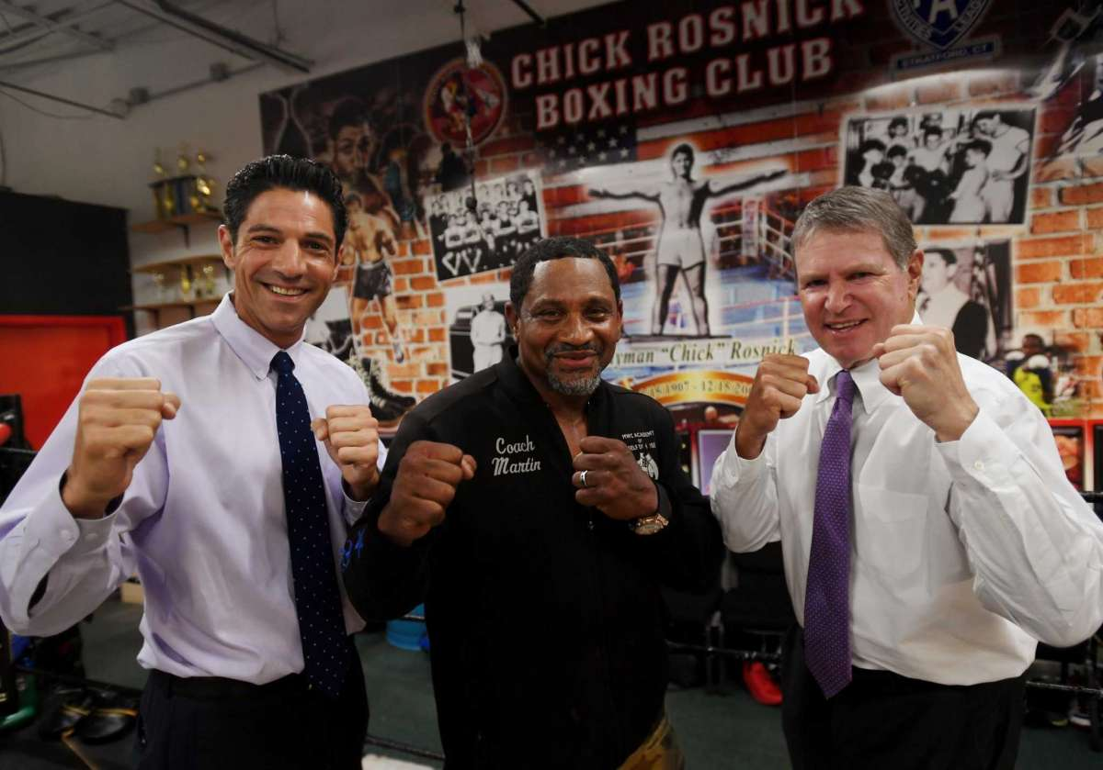

From left; Michael Rosnick, boxing Coach Martin Chisholm, and Harold Rosnick at the Chick Rosnick Boxing Club in Stratford, Conn. on Monday, August 16, 2021.
Brian A. Pounds / Hearst Connecticut Media
7
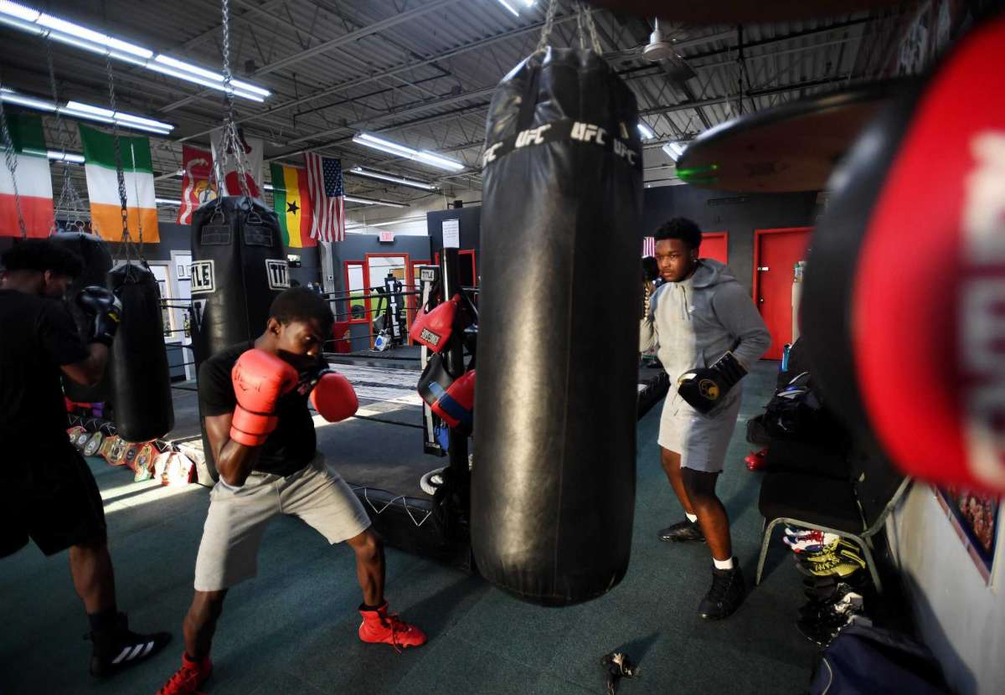

Christopher Alexis, 16, left, and Isaiah Haynes,16, both of Stratford, hit the heavy bag with their fellow boxers at the Chick Rosnick Boxing Club in Stratford, Conn. on Monday, August 16, 2021.
Brian A. Pounds / Hearst Connecticut Media

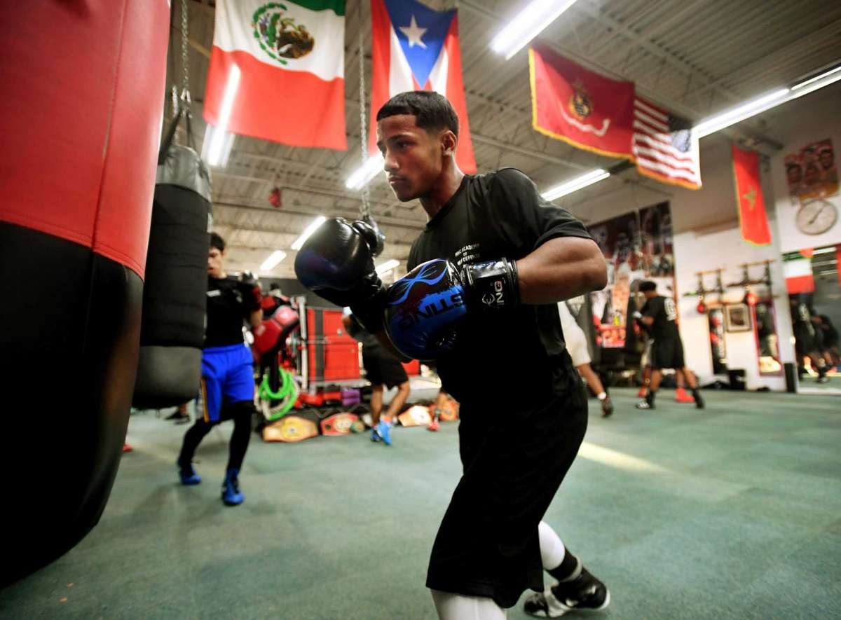
Joseph Chisholm, 15, of Stratford, hits the heavy bag along with his fellow boxers at the Chick Rosnick Boxing Club in Stratford, Conn. on Monday, August 16, 2021.
Brian A. Pounds / Hearst Connecticut Media

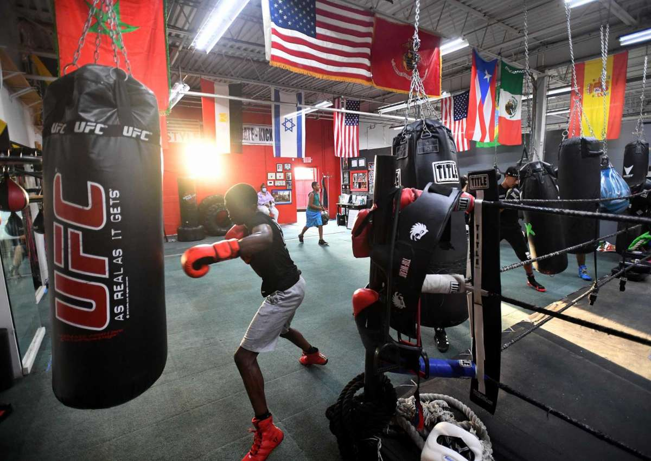
Christopher Alexis, 16, left, of Stratford, hits the heavy bag along with fellow boxers at the Chick Rosnick Boxing Club in Stratford, Conn. on Monday, August 16, 2021.
Brian A. Pounds / Hearst Connecticut Media

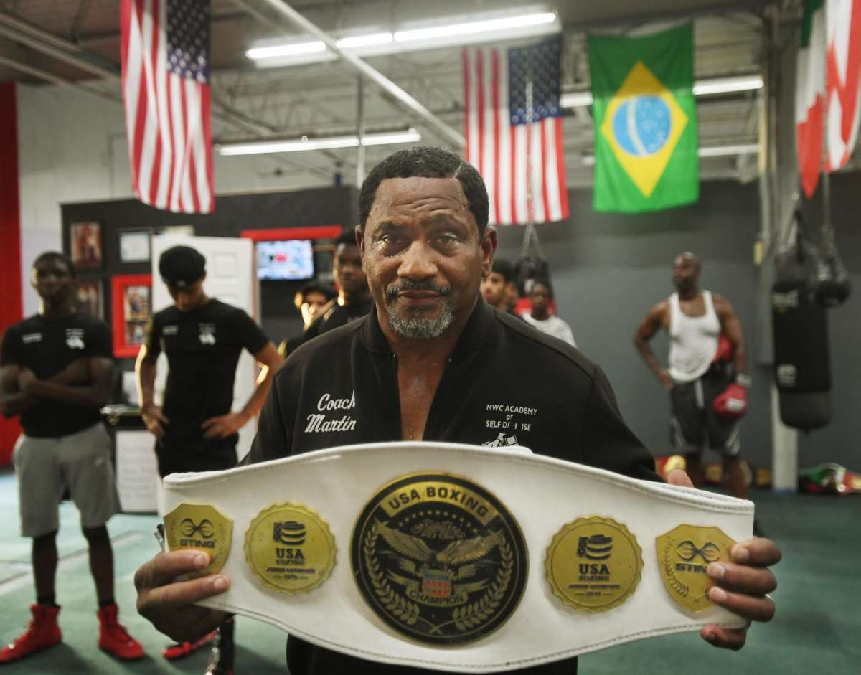
Coach Martin Chisholm, of Stratford, holds a U.S.A. title belt won by his daughter, Sumayyah Chisholm, at the Chick Rosnick Boxing Club in Stratford, Conn. on Monday, August 16, 2021.
STRATFORD — A charity boxing event next month will see two dozen fighters vie for a trophy sanctioned by USA Boxing to benefit a local youth gym.
The event, scheduled for Sept. 11 at the Trumbull Marriott, is the first fundraiser for the Chick Rosnick Boxing Club, which is based on Sniffens Lane off Main Street in Lordship.
But the tradition the club honors goes back decades to its namesake, Hyman “Chick” Rosnick, a boxing enthusiast, coach and educator who served for 36 years as director of health and physical education at the former Jewish Community Center on Park Avenue in Bridgeport.
The Stratford-based nonprofit was created by father-and-son lawyers Harold Rosnick and Michael Rosnick, of the Bridgeport-based firm Miller, Rosnick, D’Amico, August and Butler, in memory of their father and grandfather.
“My dad spent his whole career helping kids with physical education,” Harold Rosnick said during an interview at the gym Monday. “He taught myself and my brothers discipline and commitment and hard work, competition and fair play.”
When the opportunity came to help local trainer Martin Chisholm found the boxing club, Harold Rosnick said it was a no-brainer.
“We’re delighted to help out and delighted to give back,” he said. “Hopefully the same values my father taught me and my brothers can be passed on through this program.”
The Rosnicks are Stratford born and raised, Harold Rosnick said.
“I owe a lot to the town. I got a great education, I made lifelong friends to this day,” he said. “My parents were always very fond of Stratford.”
The club is housed in a gym run by Chisholm, a former Marine and martial artist who has taught self-defense to police departments in Stratford and elsewhere. He has also counseled many children on conflict resolution and substance abuse as a youth worker.
Since 2015, Chisholm and Harold Rosnick worked together to send area athletes to boxing matches, including Chisholm’s daughter, Sumayyah, a 2019 Junior Open champion.
Chisholm’s son Joseph, who also trains at the gym, is part of a group from the club headed to regional championships in Rochester, N.Y. this weekend, and hopefully the national competition in Missouri after that.
Chisholm said the trophies and championship belts that line the walls of the gym are a nice reward — but seeing the impact the sport can have on the hundreds of kids who have trained there outside of the ring is just as fulfilling.
“It allows them to set goals, it allows them to focus,” he said of the sport. “A lot of children may have a retention problem. Even if a child throws a 1-2 with a proper stance and that’s all I can get out of that child. If I can get five seconds, some of the parents are so overwhelmed when their child just focuses for five seconds.”
Once a child can focus and throw a 1-2 combination, that creates self-discipline, Chisholm said.
“We then show them they have now set a goal for themselves, which gives them self-confidence, which leads to self-respect,” Chisholm said. “When you have certain standards for yourself then you can make the proper friends, then we can persevere and do it over and over and over again.”
Michael Rosnick said those lessons are a perfect legacy for his grandfather, who many in Stratford remember as an avid golfer who owned a pro shop, and was also known for playing in bridge tournaments with his wife, Tillie.
“But his greatest achievements were the lessons of good sportsmanship and good character that he instilled in thousands of kids in his lifetime,” Michael Rosnick said. “He was an incredible role model for his family and for his community.”
The Black Tie Amateur Boxing Dinner Show is scheduled for Saturday, Sept. 11, 2021 at the Trumbull Marriott Shelton Hotel. The black-tie optional event features cocktails and dinner to precede the fights.
Cocktails and hors d’oeuvres begin at 5 p.m., with dinner at 6 p.m. and the boxing show at 7 p.m., all to be held in the Grand Ballroom of the hotel, 180 Hawley Lane, Trumbull.
Tickets are $65 for the show plus cocktails, hors d’oeuvres and dinner, and $25 for the boxing show only.
All state-mandated COVID-19 protocols will be followed. For more information and to purchase tickets in advance, call 203-551-4691.
Written By
Ethan Fry
Ethan Fry covers the town of Stratford. Prior to working at Hearst Connecticut Media, he worked at the Valley Independent Sentinel and the Journal-Inquirer of Manchester. He also has worked at the Danbury News-Times. He's a fan of irony, the New York Mets, Manchester United Football Club, classic films, and the Oxford comma.

