Hundreds attend Chick Rosnick Boxing Club Black Tie Dinner Show

​Amateur fighters "went the distance" to benefit youth and young adults in Stratford and surrounding towns

Deborah Levison, Neighbor
Posted Wed, Sep 15, 2021 at 1:00 pm ET| Updated Wed, Sep 15, 2021 at 1:05 pm ET|

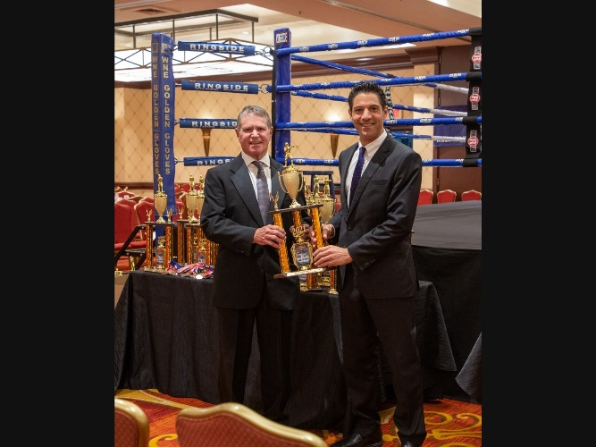

Attorneys Harold and Michael Rosnick of Miller, Rosnick, D'Amico, August and Butler, P.C., created the Chick Rosnick Boxing Club, Inc., in honor of their father and grandfather, Hyman "Chick" Rosnick, a multi-sport athlete and beloved coach and educator. (Regina Madwed / Capitol Photo, Fairfield, CT.)

The first annual Chick Rosnick Boxing Club Black Tie Amateur Boxing Dinner Show, held at the Trumbull Marriott on 9/11, drew dozens of young boxers -- both boys and girls -- from CT, MA, NY, NJ, and RI. (Regina Madwed / Capitol Photo, Fairfield, CT.)

Atty. Harold Rosnick congratulates Chris Alexis, 16, of the Chick Rosnick Boxing Club, Inc. on his win. (Regina Madwed / Capitol Photo, Fairfield, CT.)

Some 600 spectators cheered the young boxers at the Trumbull Marriott on Saturday, September 11, 2021. The event was sponsored by Duchess Restaurants, among others. (Regina Madwed / Capitol Photo, Fairfield, CT.)

Dozens of amateur male and female boxers, some as young as eight years old, from around the northeast donned their gloves for a trophy in a USA Amateur Boxing-sanctioned evening of three-round matches held at the Trumbull Marriott Hotel on 9/11.
Nearly 600 spectators arrived to cheer the fighters on.
Proceeds from the event support the Chick Rosnick Boxing Club, Inc., a youth boxing program dedicated to training, conditioning, development, discipline, and competition. The club is open to boys and girls aged four through young adult, from Stratford and surrounding towns, who want to pursue boxing for recreation as well as higher competition. Past members of the club have gone on to compete at the national level.
The Stratford-based nonprofit was created by father-and-son attorneys Harold Rosnick and Michael Rosnick in memory of their father and grandfather, Hyman "Chick" Rosnick, a lifelong boxing enthusiast, coach and educator whose retirement was declared "Chick Rosnick Day" in the City of Bridgeport and who was honored by the State Legislature for a lifetime of achievement.
"My father was a five-sport athlete with a special passion for boxing that he passed along to me," said Harold Rosnick of the Bridgeport-based law firm Miller, Rosnick, D'Amico, August and Butler, P.C. "He trained and coached generations of kids in football, baseball, basketball, swimming, and volleyball. Everyone loved him. He was not a large man, but he was larger than life."

In 1937, for his master’s degree at University of Massachusetts, Chick Rosnick wrote a thesis outlining his vision for the ideal physical education program that would promote wellbeing throughout the entire community. He implemented that vision for 36 years as Director of Health and Physical Education at the former Jewish Community Center on Park Avenue in Bridgeport, which later established the state-of-the-art Chick Rosnick Fitness Center in his honor.
"Many people remember my grandfather as an avid golfer who owned a pro shop in Stratford that sold equipment to thousands of golfers around Connecticut. Or, they recall him and my grandmother Tillie playing bridge in tournaments around the world," said Michael Rosnick, also of Miller, Rosnick, D'Amico, August and Butler, P.C. "But his greatest achievements were the lessons of good sportsmanship and good character that he instilled in thousands of kids in his lifetime. He was an incredible role model for his family and for his community.
"We continue his legacy of promoting health, discipline and competition through the new boxing club and gym that bears his name," Rosnick added.
The boxing club, located at 360 Sniffens Lane in Stratford, is housed in a registered gym run by well-known martial artist, tactical trainer and youth worker Martin Chisholm. A former marine, Chisholm served the State of Connecticut as police department tactical self-defense coordinator. He developed the "Good Reaction" tactical program for the Stratford Police Department, taught martial arts for over 20 years, and ran a youth center for nearly 30. He also served as the Stratford SWAT team's instructor for defensive tactics. And, he counseled many children on conflict resolution and substance abuse.
Since 2015, Chisholm and Harold Rosnick worked together to send area athletes to boxing matches, including Chisholm's own daughter who went to the national championships and his son who will go to nationals this December.
About:
The Chick Rosnick Boxing Club, Inc., is a registered 501(c)3 (pending) organization dedicated to teaching the art of boxing to boys and girls in the Stratford area and beyond. Its 4,000 square-foot registered facility is located at 360 Sniffens Lane, Stratford, CT. For more information, call (203) 551-4691.

