Honoring a ‘larger than life’ athlete
Facebook Twitter March 22, 2022
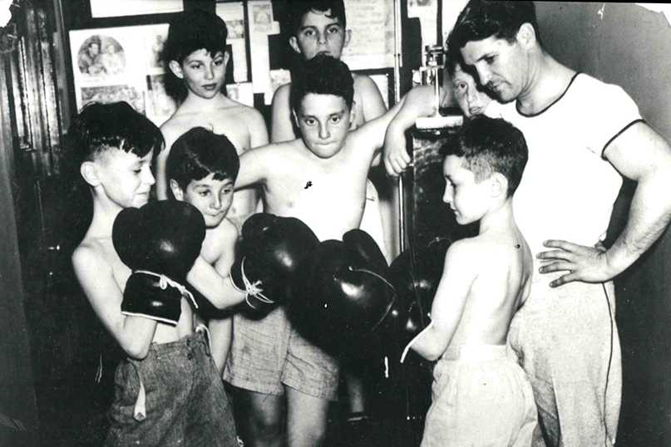
By Stacey Dresner
STRATFORD, Connecticut – As director of health and physical education at the former Bridgeport Jewish Community Center for 36 years, Hyman “Chick” Rosnick z”l, was an advocate for fitness and well-being long before aerobics classes and gym workouts became popular in the 1980s.

“He trained and coached generations of kids… Everyone loved him,” says his son, Harold “Hal” Rosnick. “He was not a large man, but he was larger than life.”
The day of Chick’s retirement in 1973 was declared “Chick Rosnick Day” in the City of Bridgeport, and he was also honored by the state legislature for a lifetime of achievement.

Now, the beloved coach and mentor from Stratford has been honored as namesake of the Chick Rosnick Boxing Club, a nonprofit created by Hal and Hal’s son Michael Rosnick, both attorneys at the Bridgeport-based law firm Miller, Rosnick, D’Amico, August and Butler, P.C.

“We continue his legacy of promoting health, discipline and competition through the new boxing club and gym that bears his name,” Michael Rosnick says, adding that the club represents more about his grandfather than just his love of boxing.

“He had the biggest, warmest heart imaginable. He cared about the community and cared about children. Physical education is in the Rosnick roots…to be involved in athletics, to learn how to win, how to lose, how to be part of a team, and most importantly, giving back to the community by doing your fair share,” he notes.

The Chick Rosnick Boxing Club got its start when Hal met Martin Chisolm, a former marine who had served the State of Connecticut as police department tactical self-defense coordinator. Chisolm developed the “Good Reaction” tactical program for the Stratford Police Department, taught martial arts for more than 20 years, ran a youth center for nearly 30 years and counseled many children on conflict resolution and substance abuse.

Chisolm was operating a gym in Stratford with the goal of training young people.
“If you have seen the Rocky movies, the gym was kind of like that,” says Hal. “He was trying to run a boxing program to help the youth of the community, both in Bridgeport and Stratford, which have some troubled areas.”
In 2015, Chisholm and Harold Rosnick began working together to send young area athletes to compete in boxing matches. Soon, Hal and his son Michael realized that the program and its mission was exactly the kind of thing his father Chick would have supported.

Last May, they founded the boxing program as a 501(c)3 nonprofit. The gym, located on the East Side of Stratford, is dedicated to training boys and girls, aged four through young adult, from Stratford and surrounding towns, who want to pursue boxing for recreation as well as for conditioning, discipline and higher competition.

“We’re attempting to work with a variety of agencies, such as probation departments, juvenile delinquency officers, police department captains, and youth facilities where we can redirect a wayward child, or a potentially wayward child, toward physical conditioning and discipline, which we think is an important life skill,” Hal explains. “We believe physical conditioning and training for boxing or martial arts has the potential to straighten out a kid and get them on the correct career path.”

In addition to support from the Rosnick family, on Sept. 11, 2021, the club hosted its first fundraiser. Held at the Trumbull Marriott Shelton Hotel, The Black-Tie Amateur Boxing Dinner Show featured cocktails and dinner followed by a USA Amateur Boxing-sanctioned evening of three-round boxing matches – headlined by the young boxers that are members of the boxing club.

More than 300 people attended the event, which raised upwards of $40,000 for the boxing club.

In the past few months, the Rosnicks have helped to fix up the boxing club’s gym, including refurbishing the boxing rings and flooring.

“It’s one of the nicest boxing rings in the state at this point,” Hal says. More importantly, he emphasizes, “It’s a safety net for these kids.”

“Tough as iron”

Born in Poland in 1912, Chick Rosnick came to the U.S. in 1914 with his family, settling in Springfield, Massachusetts.

“I must have 200 cousins in the Springfield area,” Hal laughs.

Chick was a five-sport athlete, playing football, baseball, basketball, swimming, and volleyball. He also wrestled and, while boxing wasn’t one of his main sports, he had a special passion for it – a passion he passed on to Hal.

“He was small and tough,” Hal recalls. “He was 5’ 6” but tough as iron.”

Chick graduated from East Stroudsburg State Teachers College in Pennsylvania and received his master’s degree in 1937 from the former Massachusetts Agricultural College, now the University of Massachusetts at Amherst. For that degree he wrote a thesis outlining his vision for the ideal physical education program that would promote wellbeing throughout the entire community.

In 1932, Chick became director of health and physical education at the JCC which was then located on the corner of State and Lafayette Streets in Bridgeport. The JCC had a bowling alley and pool tables in the basement and a gym on the third floor.

When the new JCC was built on Park Avenue in 1962, Chick founded the popular “Bagel Club” — a men’s club held every Sunday morning.

“The men would come and play volleyball and racquet ball, but more importantly, eat bagels and lox. In its heyday, from 1962 to the mid-70s, you would have 200-300 men show up there every Sunday for breakfast…It was just a wonderful social event,” says Hal, noting that a small group of members of the old Bagel Club still meet at Jewish Senior Services on Sundays.

Chick’s wife Matilda “Tillie” Rosnick served at the JCC as youth director for many years. They lived in Stratford where they raised their three sons and were among the founders of the town’s Temple Beth Sholom.

“He embraced his Judaism. He was a proud Jew for sure,” Hal said.

Fluent in Yiddish, he taught Yiddish classes until he was in his 90s and was known for his joke telling – in both English and Yiddish.

A member of the Jewish Hall of Fame Chick was a golf-pro and maintained a pro shop in Stratford.

After retiring in 1974, Chick and Tillie moved to Florida. They were accomplished bridge players playing as a team in tournaments all over the world. Both were life masters.

“In his early 90s he was still playing golf,” Hal says. “He remained in good condition for most of his life. He was always on the go.”

When Chick Rosnick died Dec. 15, 2004 at the age of 97 a public memorial service, attended by many of his admirers, was held at the JCC, where he had served for so long. In addition to his three sons, Chick Rosnick is survived by five grandchildren and eight great-grandchildren – one big team being raised to honor the same principles Chick supported, especially those of tikkun olam, repairing the world.

“I can only imagine the smile it would put on my grandfather’s face to walk into the Chick Rosnick Boxing Club and see what it’s about,” Michael Rosnick says. “My father and I are honored to embark on this journey with Martin Chisolm to help the youth in our community.”

Main Photo: Hyman “Chick” Rosnick in an undated photo, with some of his young boxing students at the Bridgeport JCC.

